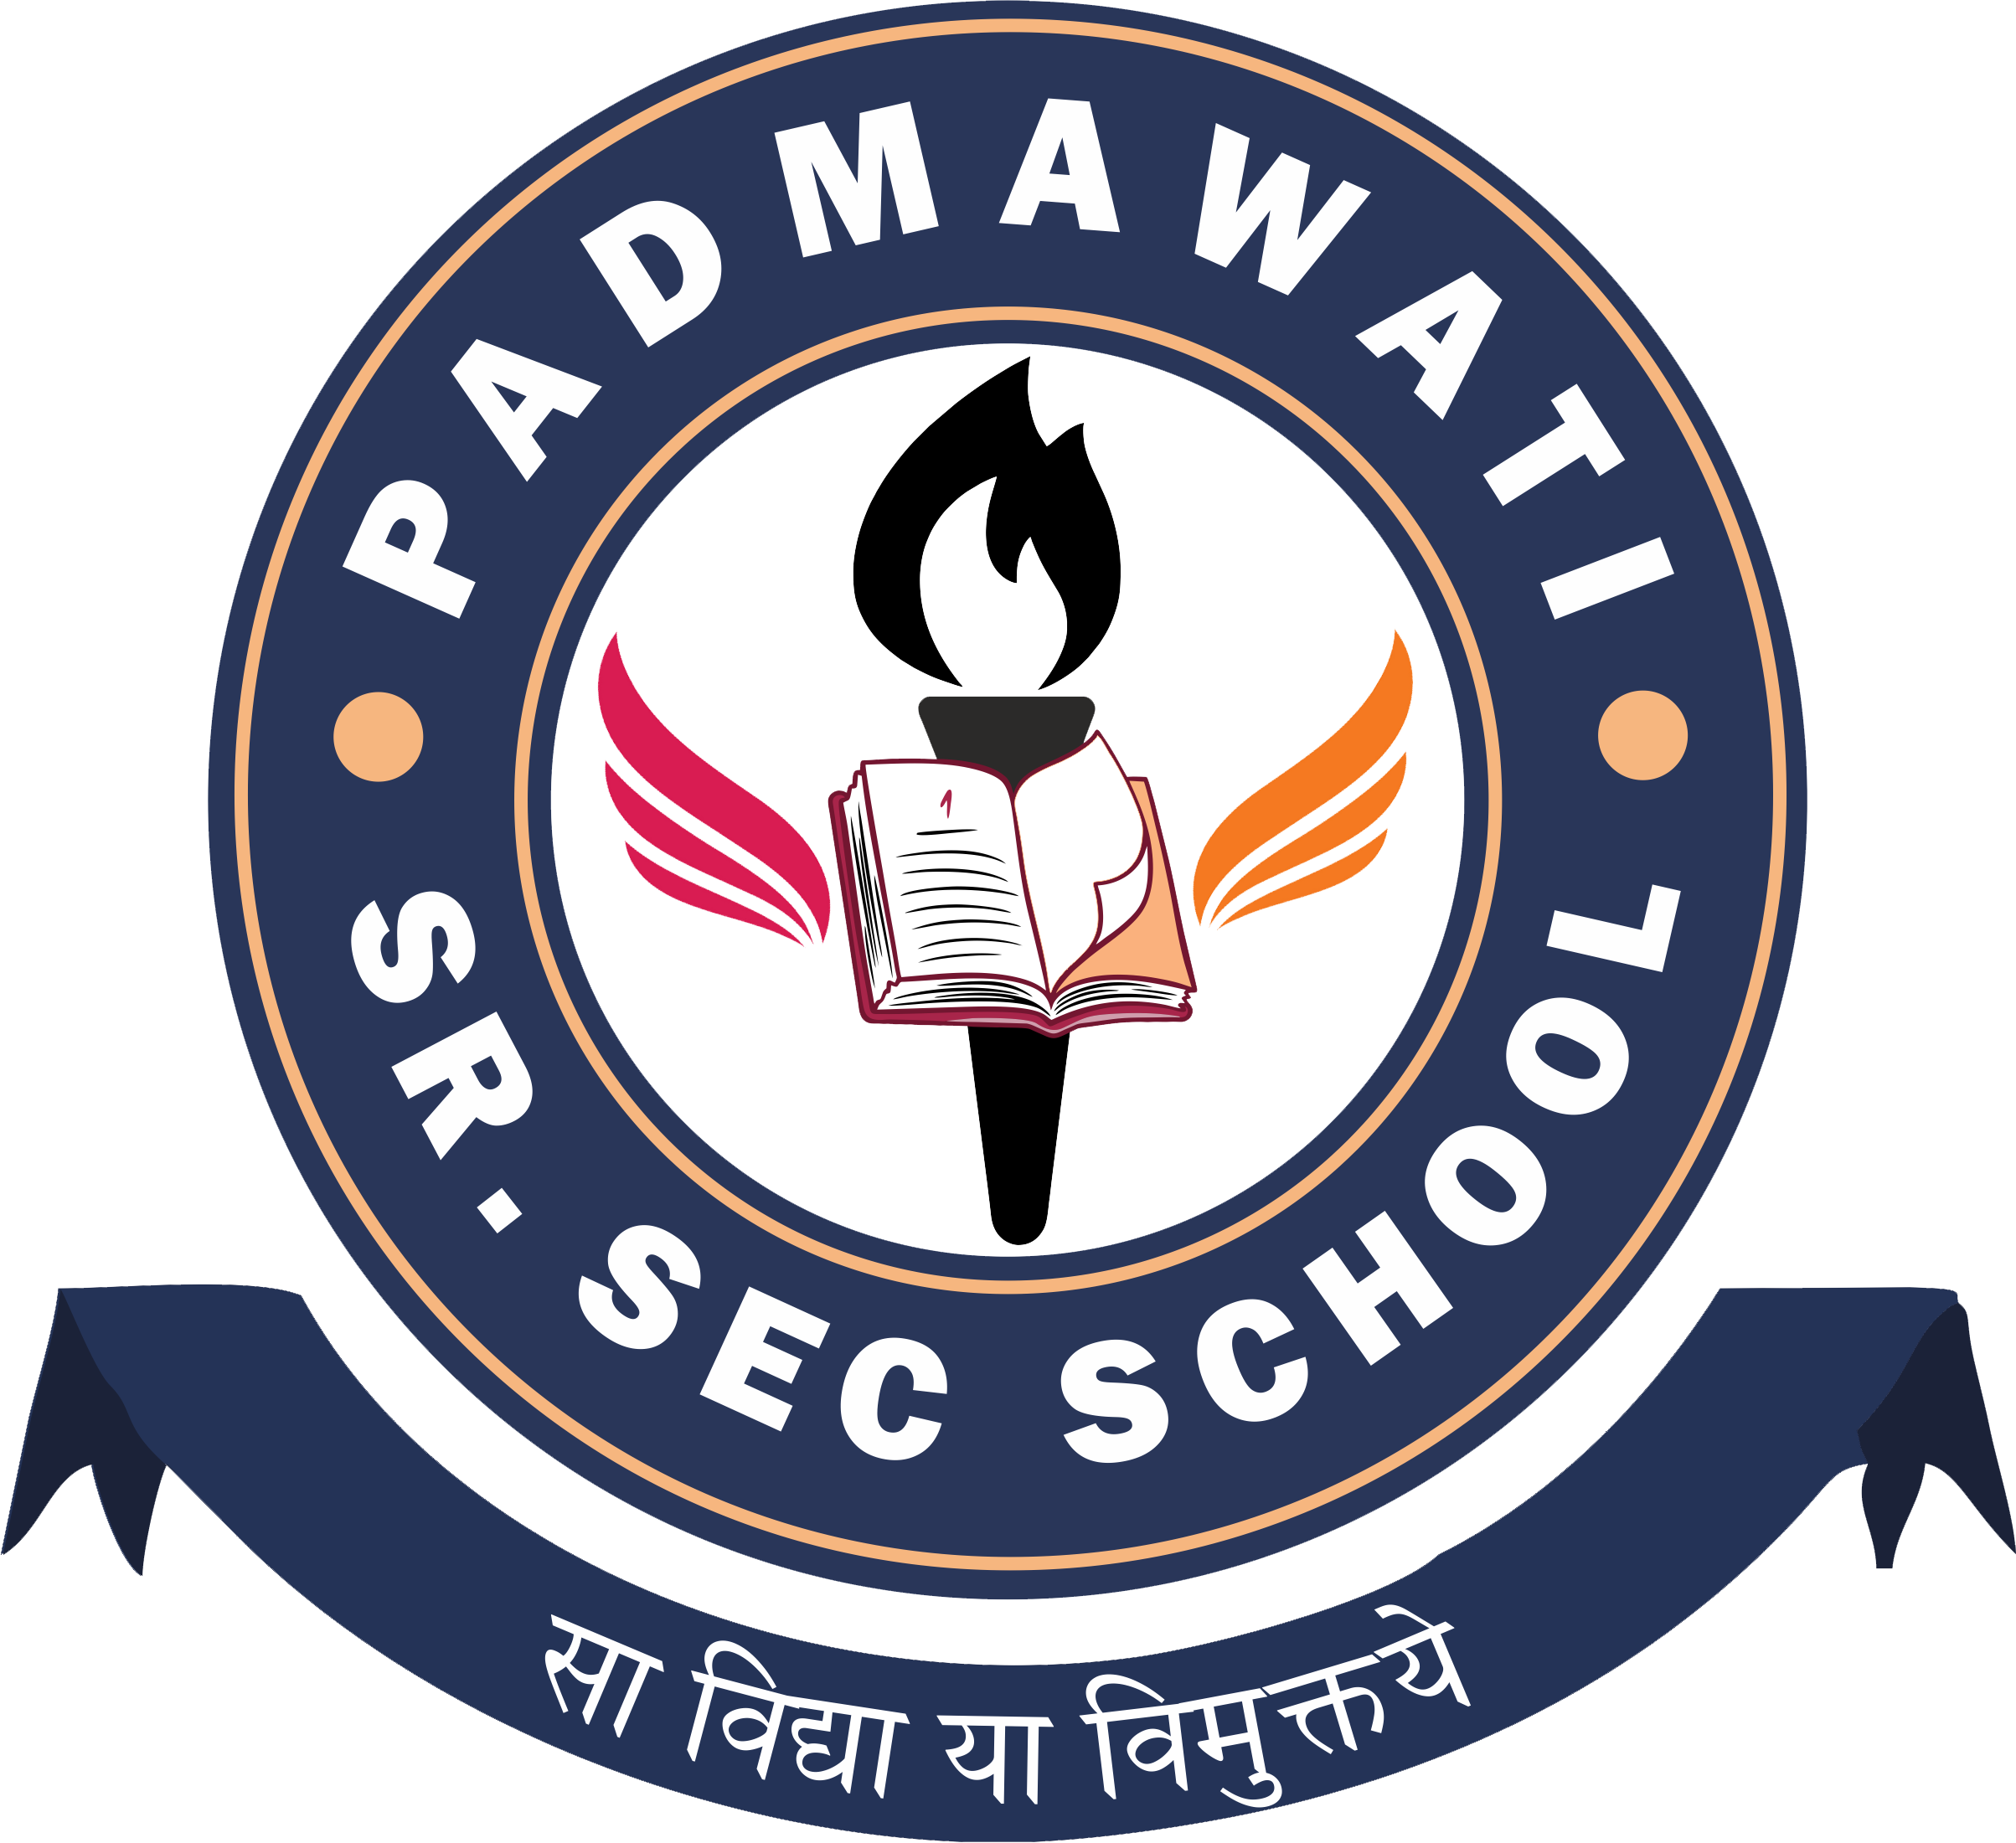
PADMAWATI SR. SEC. SCHOOL
CLASS I to XII
DATESHEET PERIODIC TEST-2 (2024-25)

DATE/  DAYS | I | II | III | IV | V | VI | VII | VIII | IX | X | XI | XII
12.08.2024  (Monday) | G.K. | Maths | Comp. | Eng. | EVS | Sci. | Eng. | Maths | Sci. | Eng. | English | Accountancy/  Physics/  History
13.08.2024 (Tuesday) | Comp. | Comp. | Eng. | Hindi | Comp. | S. St. | Sci. | Hindi | Eng. | AI | PHE/IP/  Hindi | PHE/IP/  Hindi
14.08.2024 (Wednesday) | EVS | G.K. | G.K. | Maths | G.K. | Maths | G.K. | Sans. | Hindi | Sci. | Accountancy/ Physics/  History | Biology/  Maths/  Applied Maths
16.08.2024 (Friday) | Maths | Eng. | Maths | G.K. | Maths | Sans. | Comp. | Eng. | AI | Hindi | - | P. Science
17.08.2024  (Saturday) | Eng. | Hindi | EVS | Comp. | Eng. | Hindi | S. St. | Sci. | S. Sci. | Maths | Biology/  Maths/ Applied Maths/  P. Science | Chemistry/  B. Studies/  Geography/
[  20.08.2024 (Tuesday) | Hindi | EVS | Hindi | EVS | Hindi | Comp. | Sans. | Comp. | Maths | S. Sci. | Chemistry/  B. Studies/  Geography/ | English
21.08.2024 (Wednesday) | - | - | - | - | - | G.K. | Maths | G.K. | - | - | Economics | Economics
22.08.2024 (Thursday) | - | - | - | - | - | Eng. | Hindi | S. St. | - | - | - | -

Note:
1. | Periodic Test-2 will be held during school hours.
2. | Second quarter fees must be cleared before appearing in Periodic Test-2.
3. | No re-test will be conducted for whatsoever reason.
4. | If any student is found using any unfair means, he/she‘ll be disqualified from the examination.
5. | Students must wear grey uniform only along with I D cards during examinations.
6. | Students are not allowed to wear smart watches and not to bring any mobile phone, calculator, stapler and electronic gadgets etc. If found it’ll be confiscated.
7. | Rs. 50/- fine in case you lose or forget to bring the admit card to school during examination.

